Alumni connect:
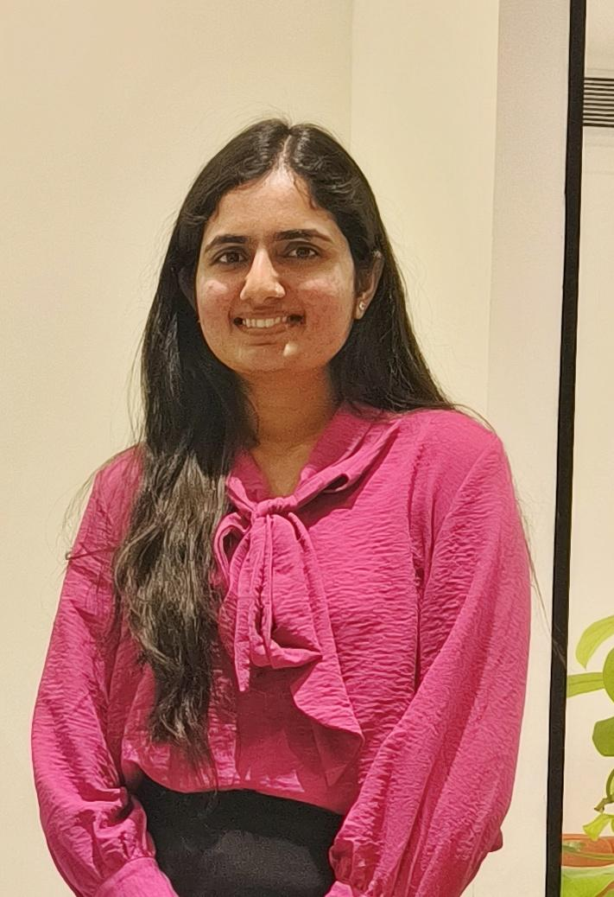
"My experience at Indira Global School of Business Studies has been exceptional. The academic curriculum, combined with the guest lectures and workshops on business analytics, finance, operations, and HR, has broadened my knowledge. Additionally, certifications in digital marketing, sales, and service excellence have been invaluable in shaping my professional journey.”
Prachi Navghare (MBA 2022-24 Batch)

“I am very Thankful to Indira Global School of Business for providing me the opportunity to get into my Dream Job. They have helped to learn the skills that are needed in the current Corporate world and also guided me and identified my potential to grow and learn faster. The learner- centric environment, Guidance & support from our Faculty Members have led me to obtain my dream job as a Branch Manager In Home First Finance Company with a good Package.”
Priyanka Koniti (MBA 2022-24 Batch)

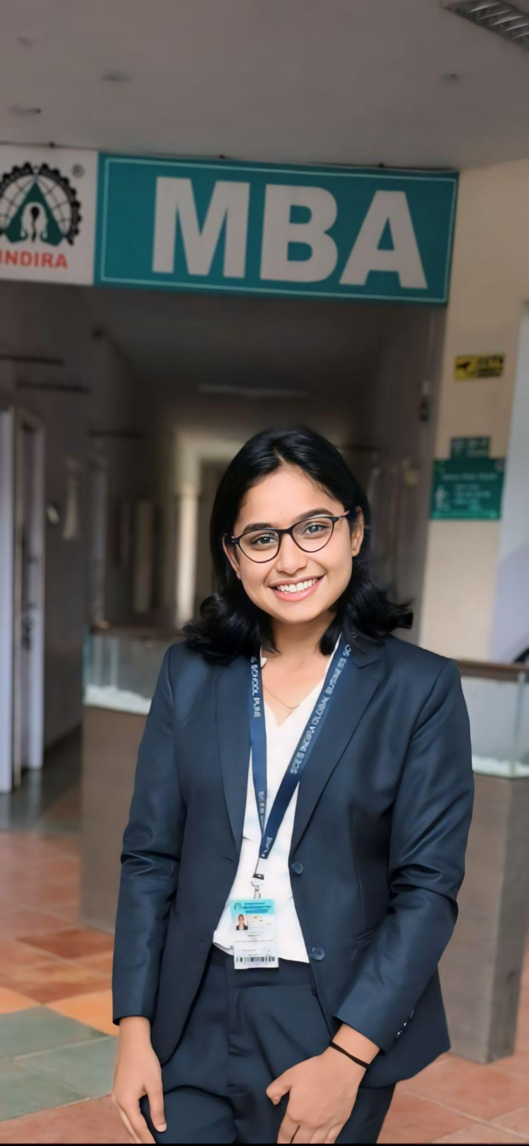
“Pursuing my MBA at IGSB was a transformative journey that exceeded my expectations in numerous ways. From the first day in the classroom, I was immersed in a collaborative environment where diverse perspectives enriched discussions. The rigorous curriculum challenged me to think critically and adapt quickly, skills that have been invaluable in my career.
Nikita Dalvi (MBA 2022-24 Batch)
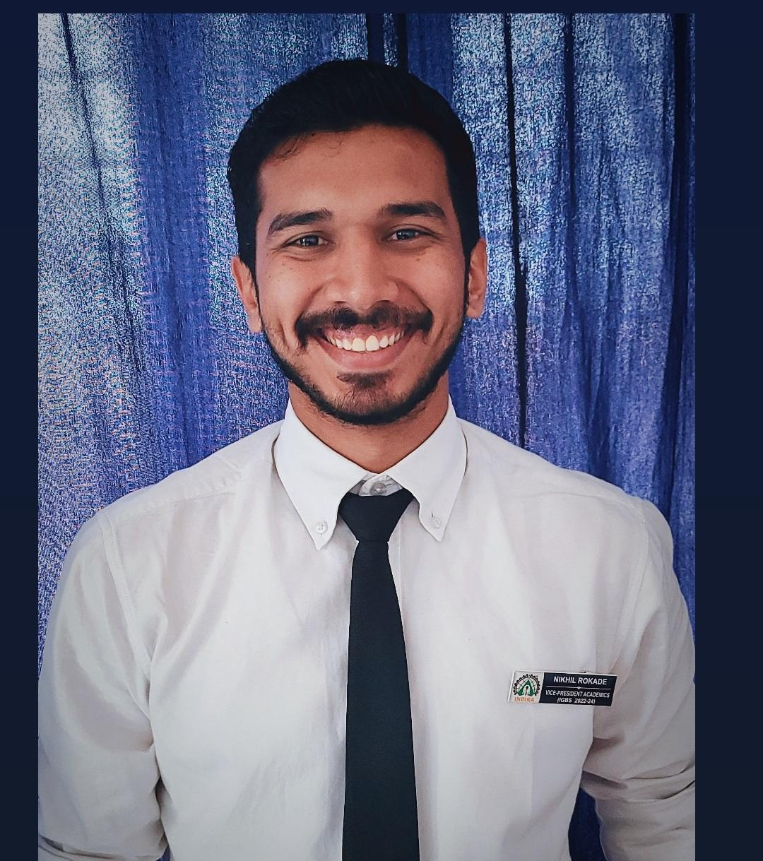
“My time at college has been nothing short of transformative, and I am grateful for the incredible support I received throughout my journey. From the moment I stepped onto campus, I felt welcomed and encouraged by both my peers and faculty. The environment fostered not only academic growth but also personal development, making it a truly enriching experience.”
Nikhil Rokade (MBA 2022-24 Batch)
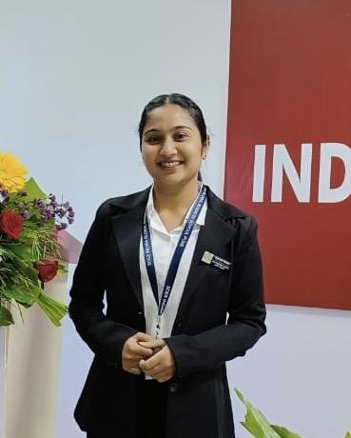
“My time at IGSB has been an incredible journey and was a game-changer for me. The faculty were always supportive, making the learning process both enjoyable and impactful. The hands-on experience was invaluable, and I’m excited to share that I received a Pre-Placement Offer (PPO) at BNY after the internship! This opportunity not only enhanced my skills but also confirmed my passion for finance. I’m really grateful to IGSB for helping me take this important step in my career.”
Suruchi Vishnu (MBA 2022-24 Batch)

